Customer Master: Magna

I have created a new customer in Magna with the Mobile no 9632171176 and Name is Divya. And Created Estimation, no 97

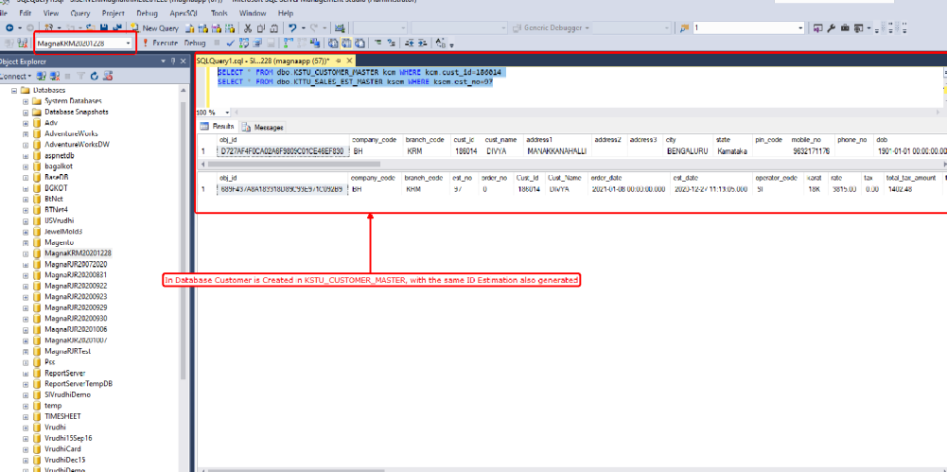

When I try to search the same customer again in Sales Estimation → Existing Customer Window with Mobile No as search Criteria.

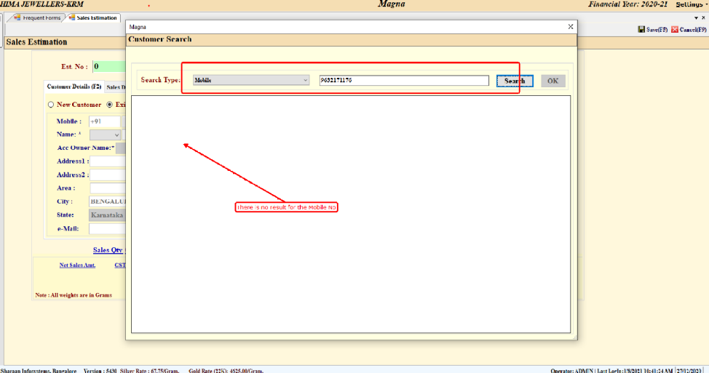

Why the customer is not listing here?

2) Whenever again we recall the same estimation.

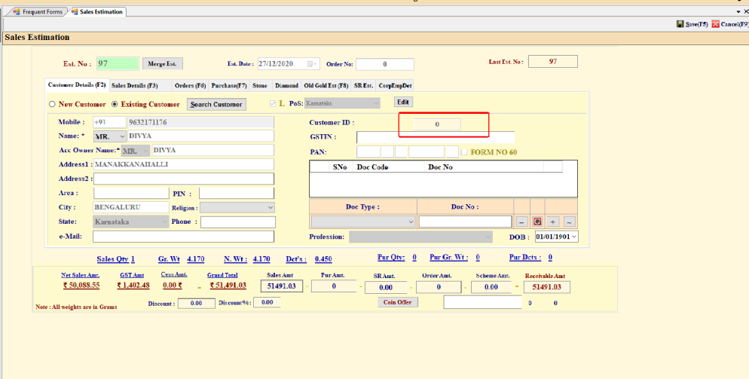

Why Customer ID is Zero here?

3) Whenever recall the estimation in Sales Billing.

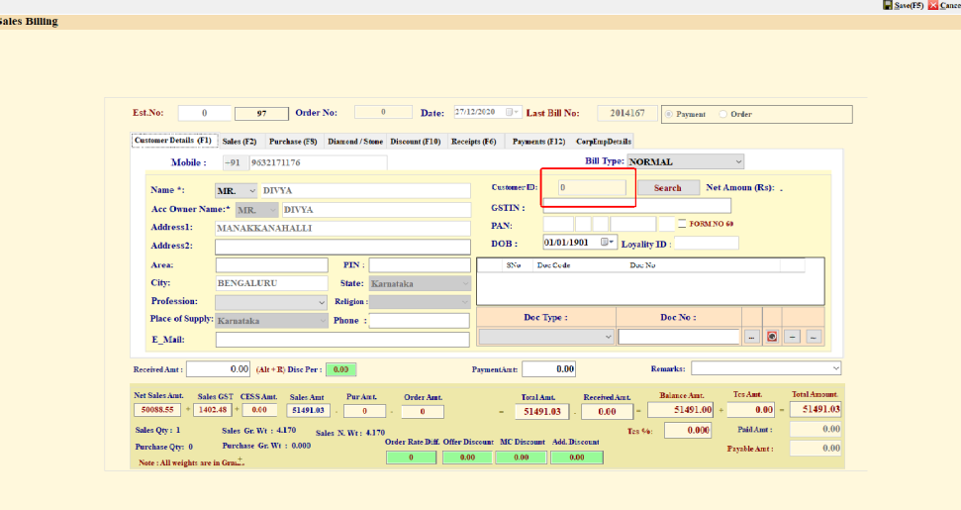

Why Customer ID is Zero here in Billing Screen?
But in Database its saving properly, I think while saving some logic is written.

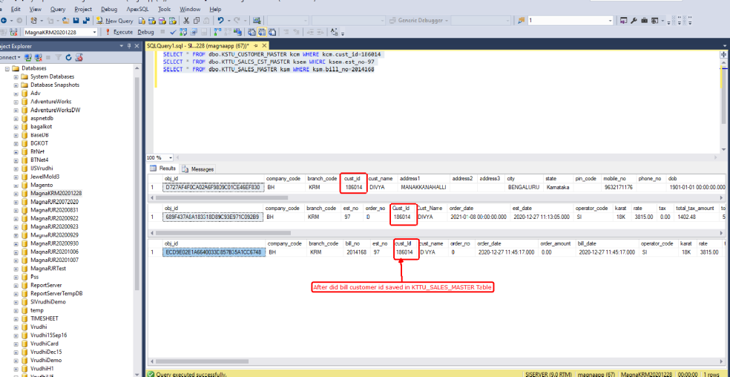

Customer Master: Prodigy

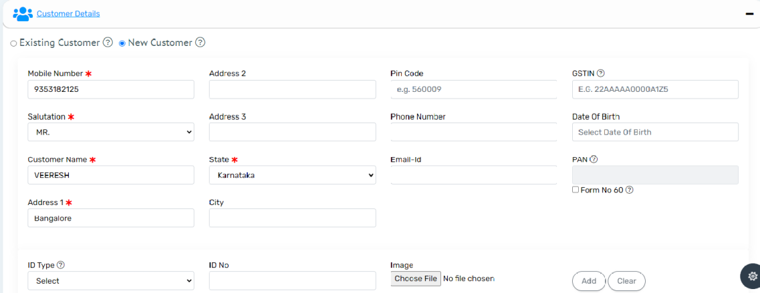

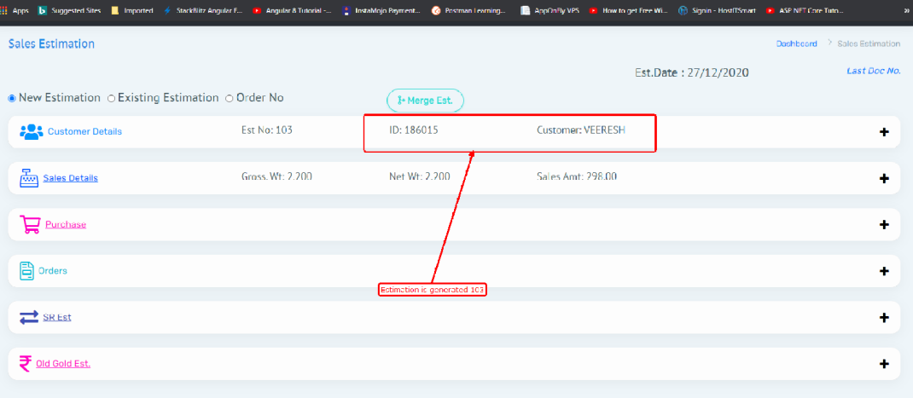

Estimation is created with New Customer Name Veeresh and Mobile No;9353182125 and Estimation no is 103

If I recall the estimation in Prodigy.

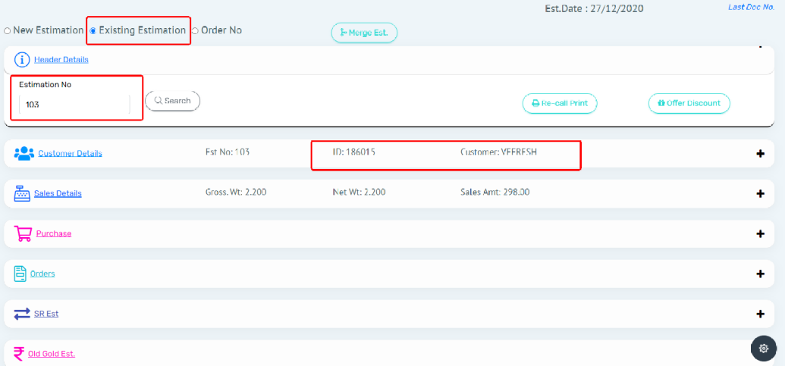

Bellow is the recall of the same estimation in Magna Application.

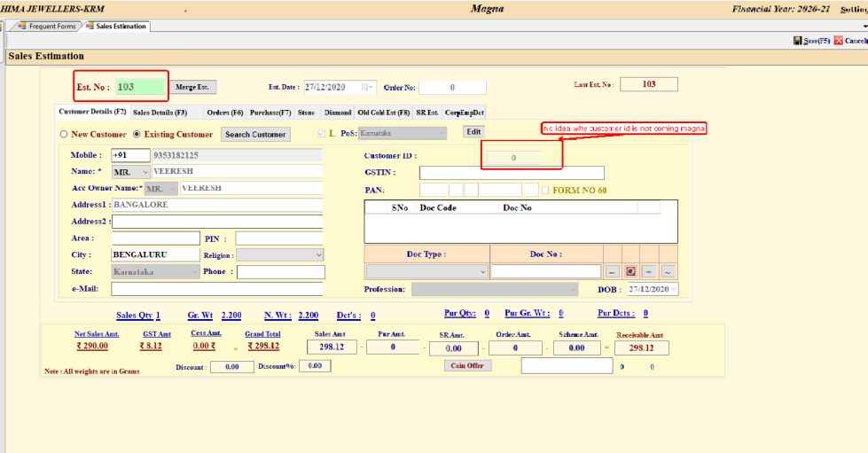

Estimation Recall in Prodigy for sales Billing.

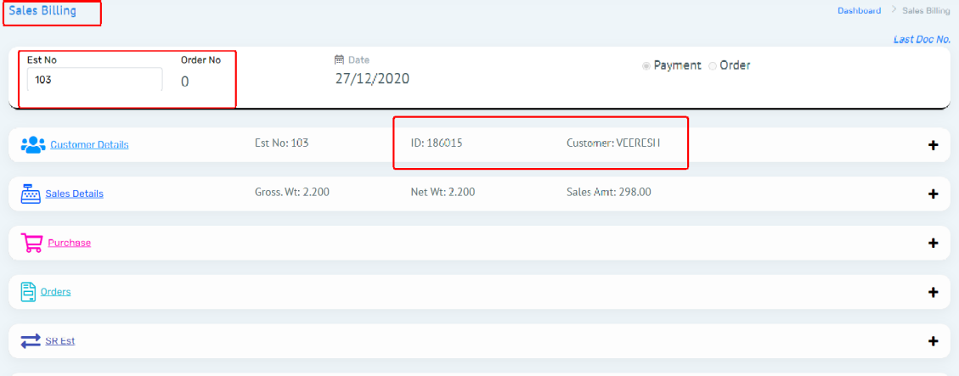

The same estimation called in Magna for Billing

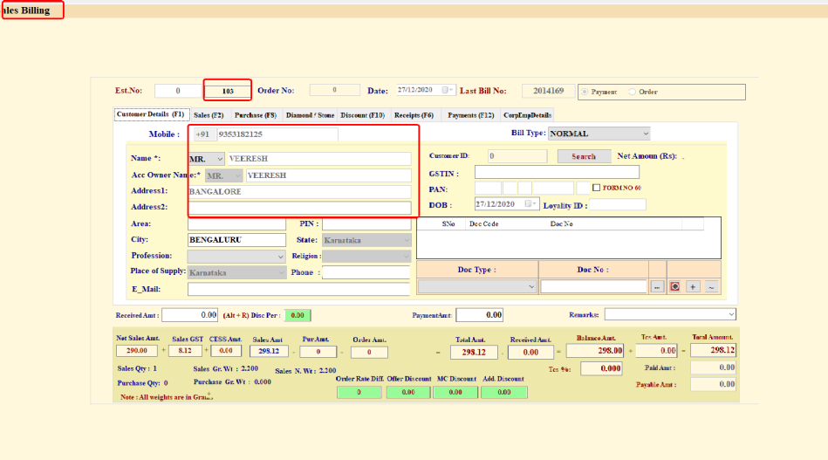

But I did bill in Prodigy:

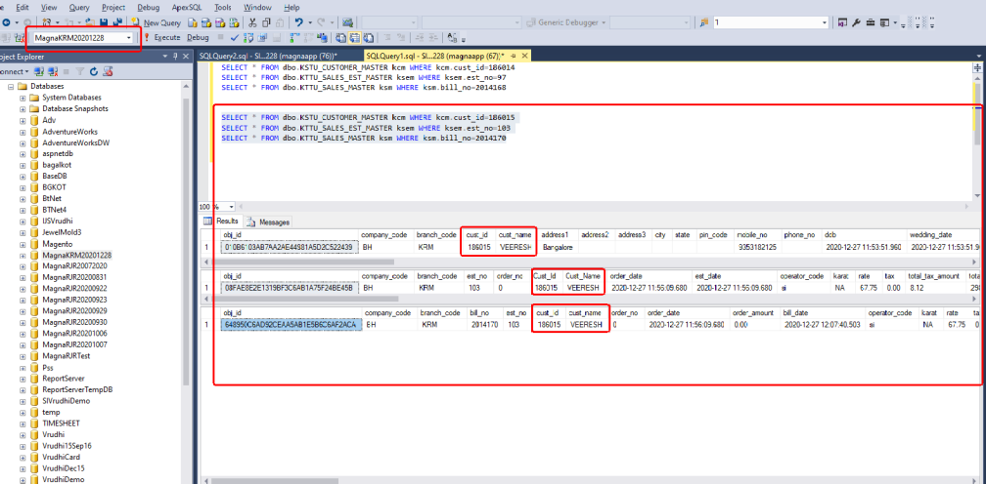

Sales Details as saved like above. There is no miss match we identified related Customer ID in prodigy.

I haven’t identified any miss match with New customer creation, if anybody find please let us know and explain us.

Still Issue with customer loading I guessed the following scenarios

1) The issue might be choosing Existing Customer

2) The customer chosen for creating estimation is not synced to the local database table KSTU_CUSTOMER_MASTER.

3) The customer records might be duplicated in mis.Customer Table or KSTU_CUSTOMER_MASTER Table.

4) Is there any missmatch of ID’s related to mis.Customer to KSTU_CUSTOMER_MASTER Table.

5) Implementation of Customer Logic might be wrong in Prodigy. (Is this is the case we need code level help from magna person who implemented the logic.)

(Above point s are just assumptions from the developer point of view)

Regards
Prodigy Team.

